The relationship between dental cavities & the use of fluoridated toothpaste + water

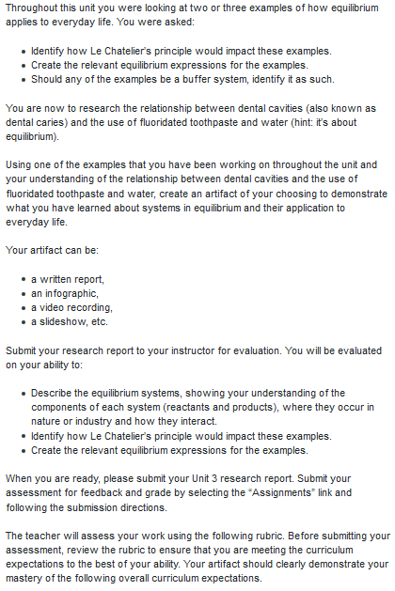

E1. “Analyse chemical equilibrium processes, and assess their impact on biological, biochemical, and technological systems;”
Level 4 (80-100%):
You described the equilibrium systems, showing your understanding of the components of each system (reactants and products), where they occur in nature or industry and how they interact with a high degree of effectiveness

E3. “Demonstrate an understanding of the concept of dynamic equilibrium and the variables that cause shifts in the equilibrium of chemical systems.”
Level 4 (80-100%):
You identified how changes to the system would impact the equilibrium and you created the relevant equilibrium expressions with a high degree of effectiveness.

Notes:
“Fluoride does not prevent cavities, but it does slow down the demineralization process. When fluoride ions are present, they can form a tough coating over the enamel. This coating helps protect the enamel as it repairs itself. Yes, your teeth can repair themselves! When the acid levels in your mouth are low and you eat calcium-rich foods, your teeth can remineralize.” (quote)
“Whenever possible, brush with a fluoride toothpaste after you eat. If you can’t brush your teeth, rinse your mouth with water. This will help raise the pH of your mouth closer to a neutral 7 and will force the chemical reaction back to the left side.”(quote)
https://letstalkscience.ca/educational-resources/stem-in-context/how-can-chemistry-help-you-take-care-your-teeth
==
How does it work – “The amount of fluoroapatite, another mineral present in enamel, reduces the critical pH because fluoroapatite (Ca₅(PO₄)₃F) is free of hydroxide. It is less soluble than calcium hydroxyapatite in acidic conditions. Fluoridating teeth protects teeth against acid-erosion by displacing hydroxide with a fluoride ion.”
Why does it matter – you don’t want rotting teeth
Facts - Acidic conditions in the mouth are what contribute to tooth erosion.
Reactants/Products – (use eq)
State of Equilibrium (use eq)
Break this equation down: calcium hydroxyapatite
Ca₁₀(PO₄)₆(OH)₂(s) ⇄ 10 Ca²⁺(aq) + 6 PO₄^{3–} (aq) + 2 OH–(aq)
https://uwaterloo.ca/chem13-news-magazine/december-2015-january-2016/chemistry/critical-ph-and-chatelier-how-everyday-substances-and-habits
break down equation into what it is biologically and relate it to real life scenarios
**use doc: draft infographic as base
K >1 = more products = breaking down
Le Chatelier’s principle – adding fluoride to get the reaction to move to the left because of the hydroxide (on the right – don’t want it)

